**SSN COLLEGE OF ENGINEERING, KALAVAKKAM**

**DEPARTMENT OF COMPUTER SCIENCE AND ENGINEERING**

**UCS1712 – GRAPHICS AND MULTIMEDIA LAB**

**------------------------------------------------------------------------------------------------------------ Lab Exercise 1 : Study of Basic Output Primitives in C++ using OpenGL**

**Aim:**

1.To create an output window using OPENGL and to draw the following basic output primitives– POINTS, LINES, LINE_STRIP, LINE_LOOP, TRIANGLES, QUADS, QUAD_STRIP, POLYGON.

2.To create an output window and draw a checkerboard using OpenGL.

3.To create an output window and draw a house using POINTS,LINES,TRIANGLES and QUADS/POLYGON.

a). To create an output window using OPENGL and to draw the following basic output primitives– POINTS, LINES, LINE_STRIP, LINE_LOOP, TRIANGLES, QUADS, QUAD_STRIP, POLYGON.

***Points:***

| *#include<GLUT/glut.h>  void myInit() {  glClearColor(1.0,0.7,0.5,0.0);  glColor3f(0.2f,0.3f,0.4f);  glPointSize(5);  glMatrixMode(GL_PROJECTION);  glLoadIdentity();  gluOrtho2D(0.0,640.0,0.0,480.0);  }  void myDisplay() {  glClear(GL_COLOR_BUFFER_BIT);  glBegin(GL_POINTS);  glVertex2d(150,100);  glVertex2d(100,230);  glVertex2d(170,130);  glVertex2d(300,350);  glEnd();  glFlush();  }  int main(int argc,char* argv[]) {  glutInit(&argc,argv);  glutInitDisplayMode(GLUT_SINGLE|GLUT_RGB);  glutInitWindowSize(640,480);  glutCreateWindow("First Exercise");  glutDisplayFunc(myDisplay);  myInit();  glutMainLoop();  return 1;  }* |
| --- |

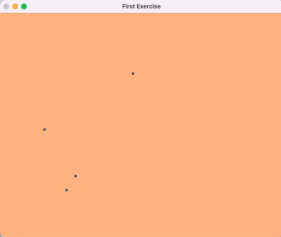

*LINES:*

| *#include<GLUT/glut.h>  void myInit() { glClearColor(1.0,0.7,0.5,0.0);  glColor3f(0.2f,0.3f,0.4f);  glPointSize(5);  glMatrixMode(GL_PROJECTION);  glLoadIdentity();  gluOrtho2D(0.0,640.0,0.0,480.0);  }  void myDisplay() {  glClear(GL_COLOR_BUFFER_BIT);  glBegin(GL_LINES);  glVertex2d(150,100);  glVertex2d(100,230);  glVertex2d(170,130);  glVertex2d(300,350);  glEnd();  glFlush();  }  int main(int argc,char* argv[]) {  glutInit(&argc,argv);  glutInitDisplayMode(GLUT_SINGLE|GLUT_RGB);  glutInitWindowSize(640,480);  glutCreateWindow("First Exercise");  glutDisplayFunc(myDisplay);  myInit();  glutMainLoop();  return 1;  }* |
| --- |

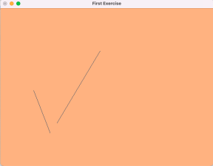

*LINE_STRIP:*

| *#include<GLUT/glut.h>  void myInit() {  glClearColor(1.0,0.7,0.5,0.0);  glColor3f(0.2f,0.3f,0.4f);  glPointSize(5);  glMatrixMode(GL_PROJECTION);  glLoadIdentity();  gluOrtho2D(0.0,640.0,0.0,480.0);  }  void myDisplay() {  glClear(GL_COLOR_BUFFER_BIT);  glBegin(GL_LINE_STRIP);  glVertex2d(150,100);  glVertex2d(100,230);  glVertex2d(170,130);  glVertex2d(300,350);  glEnd();  glFlush(); }  int main(int argc,char* argv[]) {  glutInit(&argc,argv);  glutInitDisplayMode(GLUT_SINGLE|GLUT_RGB);  glutInitWindowSize(640,480);  glutCreateWindow("First Exercise");  glutDisplayFunc(myDisplay);  myInit();  glutMainLoop();  return 1;  }* |
| --- |

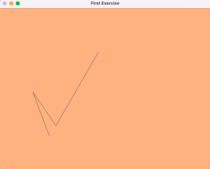

*LINE_LOOP:*

| *#include<GLUT/glut.h>  void myInit() { glClearColor(1.0,0.7,0.5,0.0);  glColor3f(0.2f,0.3f,0.4f);  glPointSize(5);  glMatrixMode(GL_PROJECTION);  glLoadIdentity();  gluOrtho2D(0.0,640.0,0.0,480.0);  }  void myDisplay() {  glClear(GL_COLOR_BUFFER_BIT);  glBegin(GL_LINE_LOOP);  glVertex2d(150,100);  glVertex2d(100,230);  glVertex2d(170,130);  glVertex2d(300,350);  glEnd();  glFlush();  }  int main(int argc,char* argv[]) {  glutInit(&argc,argv);  glutInitDisplayMode(GLUT_SINGLE|GLUT_RGB);  glutInitWindowSize(640,480);  glutCreateWindow("First Exercise");  glutDisplayFunc(myDisplay);  myInit();  glutMainLoop();  return 1;  }* |
| --- |

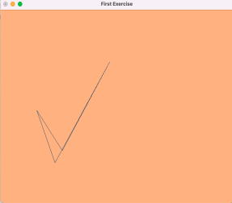

*TRIANGLES:*

| *#include<GLUT/glut.h>  void myInit() {  glClearColor(1.0,0.7,0.5,0.0);  glColor3f(0.2f,0.3f,0.4f);  glPointSize(5);  glMatrixMode(GL_PROJECTION);  glLoadIdentity();  gluOrtho2D(0.0,640.0,0.0,480.0);  }  void myDisplay() {  glClear(GL_COLOR_BUFFER_BIT);  glBegin(GL_TRIANGLES);  glVertex2d(150,100);  glVertex2d(100,230);  glVertex2d(170,130);  glVertex2d(300,350); glEnd();  glFlush();  }  int main(int argc,char* argv[]) {  glutInit(&argc,argv);  glutInitDisplayMode(GLUT_SINGLE|GLUT_RGB);  glutInitWindowSize(640,480);  glutCreateWindow("First Exercise");  glutDisplayFunc(myDisplay);  myInit();  glutMainLoop();  return 1;  }* |
| --- |

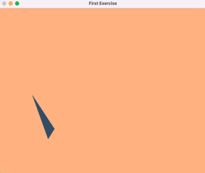

*QUADS:*

| *#include<GLUT/glut.h>  void myInit() {  glClearColor(1.0,0.7,0.5,0.0);  glColor3f(0.2f,0.3f,0.4f);  glPointSize(5);  glMatrixMode(GL_PROJECTION);  glLoadIdentity();  gluOrtho2D(0.0,640.0,0.0,480.0);  }  void myDisplay() {  glClear(GL_COLOR_BUFFER_BIT);  glBegin(GL_QUADS);  glVertex2d(150,200);  glVertex2d(100,130);  glVertex2d(250,130);  glVertex2d(300,200);  glEnd();  glFlush();  }  int main(int argc,char* argv[]) {  glutInit(&argc,argv);  glutInitDisplayMode(GLUT_SINGLE|GLUT_RGB);  glutInitWindowSize(640,480);  glutCreateWindow("First Exercise");  glutDisplayFunc(myDisplay);  myInit();  glutMainLoop(); return 1;  }* |
| --- |

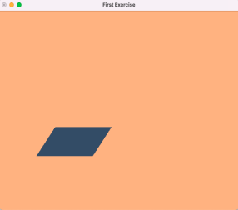

*QUAD_STRIP:*

| *#include<GLUT/glut.h>  void myInit() {  glClearColor(1.0,0.7,0.5,0.0);  glColor3f(0.2f,0.3f,0.4f);  glPointSize(5);  glMatrixMode(GL_PROJECTION);  glLoadIdentity();  gluOrtho2D(0.0,640.0,0.0,480.0);  }  void myDisplay() {  glClear(GL_COLOR_BUFFER_BIT);  glBegin(GL_QUAD_STRIP);  glVertex2d(150,200);  glVertex2d(100,130);  glVertex2d(250,130);  glVertex2d(300,200);  glEnd();  glFlush();  }  int main(int argc,char* argv[]) {  glutInit(&argc,argv);  glutInitDisplayMode(GLUT_SINGLE|GLUT_RGB);  glutInitWindowSize(640,480);  glutCreateWindow("First Exercise");  glutDisplayFunc(myDisplay);  myInit();  glutMainLoop();  return 1;  }* |
| --- |

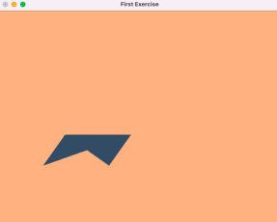

*POLYGON:*

| *#include<GLUT/glut.h>  void myInit() {  glClearColor(1.0,0.7,0.5,0.0);  glColor3f(0.2f,0.3f,0.4f);  glPointSize(5);  glMatrixMode(GL_PROJECTION);  glLoadIdentity();  gluOrtho2D(0.0,640.0,0.0,480.0);  }  void myDisplay() {  glClear(GL_COLOR_BUFFER_BIT);  glBegin(GL_POLYGON);  glVertex2d(120,100);  glVertex2d(100,150);  glVertex2d(150,200);  glVertex2d(160,150);  glVertex2d(140,100);  glEnd();  glFlush();  }  int main(int argc,char* argv[]) {  glutInit(&argc,argv);  glutInitDisplayMode(GLUT_SINGLE|GLUT_RGB);  glutInitWindowSize(640,480);  glutCreateWindow("First Exercise"); glutDisplayFunc(myDisplay);  myInit();  glutMainLoop();  return 1;  }* |
| --- |

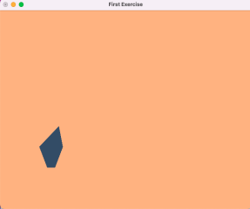

b) To create an output window and draw a checkerboard using OpenGL.

| *#include<GLUT/glut.h>  void myInit() {  glClearColor(1.0,1.0,1.0,0.0);  glPointSize(7);  glMatrixMode(GL_PROJECTION);  glLoadIdentity();  gluOrtho2D(0.0,480.0,0.0,480.0);  }  void drawsquare(int x1,int y1,int x2,int y2,int x3,int y3,int x4,int y4,int clr)  {  if(clr==1)  glColor3f(0.0f,0.0f,0.0f);  else  glColor3f(1.0f,1.0f,1.0f); glBegin(GL_QUADS);  glVertex2d(x1,y1);  glVertex2d(x2,y2);  glVertex2d(x3,y3);  glVertex2d(x4,y4);  glEnd();  }  void myDisplay() {  glClear(GL_COLOR_BUFFER_BIT);  int clr=1;  for(int i=0;i<480;i+=60)  {  for(int j=0;j<480;j+=60)  {  drawsquare(i, j, i, j+60, i+60, j+60, i+60, j,clr);  if(clr==1)  clr=0;  else  clr=1;  }  if(clr==1)  clr=0;  else  clr=1;  }  glFlush();  }  int main(int argc,char* argv[]) {  glutInit(&argc,argv);  glutInitDisplayMode(GLUT_SINGLE|GLUT_RGB);  glutInitWindowSize(480,480);  glutCreateWindow("First Exercise");  glutDisplayFunc(myDisplay);  myInit();  glutMainLoop();  return 1;* |
| --- |

*}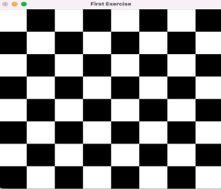*

c) To create an output window and draw a house using POINTS,LINES,TRAINGLES and QUADS/POLYGON.

| *#include<GLUT/glut.h>  void myInit() {  glClearColor(1.0,1.0,1.0,0.0);  glPointSize(5);  glMatrixMode(GL_PROJECTION);  glLoadIdentity();  gluOrtho2D(0.0,640.0,0.0,480.0);  } void myDisplay() { glClear(GL_COLOR_BUFFER_BIT);  glColor3f(0.0f,0.3f,0.8f);  glBegin(GL_TRIANGLES);  glVertex2i(120,240);  glVertex2i(195,300);  glVertex2i(270,240);  glEnd();  glColor3f(0.3f,0.3f,0.8f);  glBegin(GL_QUADS);  glVertex2i(120,100);  glVertex2i(270,100);  glVertex2i(270,240);  glVertex2i(120,240);  glEnd();  glBegin(GL_QUADS);  glVertex2i(195,300);  glVertex2i(460,300);  glVertex2i(520,240);  glVertex2i(270,240);  glEnd();  glColor3f(0.0f,0.3f,0.8f);  glBegin(GL_QUADS);  glVertex2i(270,240);  glVertex2i(520,240);  glVertex2i(520,100);  glVertex2i(270,100);   glEnd();  glBegin(GL_QUADS);  glVertex2i(270,240);  glVertex2i(520,240);  glVertex2i(520,100);  glVertex2i(270,100);  glEnd();  glColor3f(0.0f,0.0f,0.0f);  glBegin(GL_QUADS);  glVertex2i(270,240);  glVertex2i(520,240);  glVertex2i(520,100);  glVertex2i(270,100);  glEnd();  glFlush();  }  int main(int argc,char* argv[]) {  glutInit(&argc,argv);  glutInitDisplayMode(GLUT_SINGLE|GLUT_RGB);  glutInitWindowSize(640,480);  glutCreateWindow("House");  glutDisplayFunc(myDisplay);  myInit();  glutMainLoop();  return 1;  }* |
| --- |

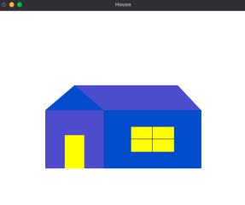

**Learning Outcome:**

1. Learnt how to draw POINTS, LINES, LINE_STRIP, LINE_LOOP, TRIANGLES, QUADS, QUAD_STRIP, POLYGONusing OPENGL.

2. I Learned to draw a checkerboard using OpenGL.

3. Was able to draw a house using POINTS,LINES,TRIANGLES and QUADS/POLYGON.